Leonard Cheshire

Gender Pay Gap Report – 2024

As a care organisation and charity in the UK, we strive to build a fairer, more inclusive society – one that recognises the positive contributions we all make, and where we are all proud to play our part.

In keeping with this, Leonard Cheshire is committed to building a workplace that is diverse and inclusive for our employees. Through various initiatives and strategies, we work hard to attract and retain employees, developing and offering rewarding careers to them regardless of disability, race, gender, sexual orientation, religion or belief, or age.

We are actively identifying and removing barriers and constraints that may impact negatively on our employees’ experience of Leonard Cheshire as an inclusive workplace.

This report covers statutory gender pay gap reporting[1].

# Gender pay reporting

The Equality Act 2010 (Gender Pay Gap Information) Regulations 2017 requires us to conduct Gender Pay Reporting. This report is based on a snapshot from Leonard Cheshire on 5 April 2024. We have applied the standard methodologies required by the regulations.

# Organisational context

At the assessment date, Leonard Cheshire was a charity supporting disabled people in the UK to fulfil their potential and live the lives they choose. Most of our workforce was employed in our services (94%). In line with norms in the social care and charity sectors, most of our employees are female (74%).

# Headline gender pay gap

The gender pay gap is defined as the difference between the mean or median hourly rate of pay that male and female employees receive.

The median pay gap is the difference between the midpoints in the ranges of hourly earnings of men and women. The mean pay gap is the difference between average hourly earnings of men and women.

At Leonard Cheshire there is a median pay gap of -**0.2%**, compared to a UK median of **7.0%** in favour of men. For the not-for-profit sector, the median pay gap is **16.1**%. The Leonard Cheshire mean pay gap is **2.9%**, compared to the UK mean pay gap of 11% in favour of men. The not-for-profit mean pay gap is **12.7%**. Leonard Cheshire is favourably positioned against both the not-for-profit sector and the broader market. [2]

Leonard Cheshire does not operate a bonus scheme, so the figures reflected are for ordinary earnings only.

**Market comparison**

The following table reflects our median and mean pay gap figures, compared against gender pay gap ratios from the Office of National Statistics (ONS).

|  |  |  |  |
| --- | --- | --- | --- |
| Organisation/source | Category | Median | Mean |
| Leonard Cheshire | All employees | -0.2% | 2.9% |
| ONS ASHE gender tables | Not-for-Profit fulltime employees | 12.0% | 12.7% |
| ONS ASHE gender tables | Not-for-Profit all employees | 16.1% | 14.7% |
| ONS ASHE gender tables | All fulltime employees | 7.0% | 11.0% |
| ONS ASHE gender tables | All employees | 13.1% | 13.8% |

The data in the above table is also reflected in the graph below:

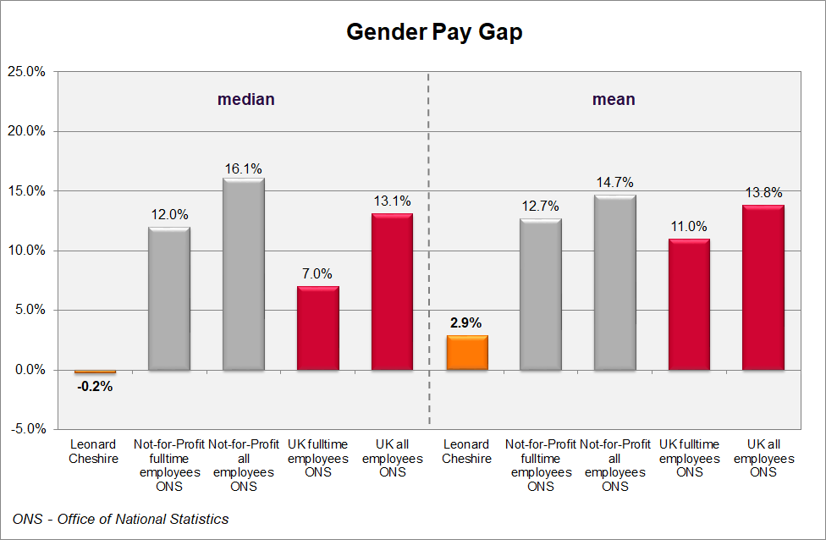

**Comparison to previous years**

The table below shows the historical pay gap figures for the past five years.

|  |  |  |
| --- | --- | --- |
| Year | Median | Mean |
| 2020 | 0.0% | 7.8% |
| 2021 | 0.4% | 5.3% |
| 2022 | 0.3% | 8.1% |
| 2023 | -0.8% | 8.6% |
| 2024 | -0.2% | 2.9% |

The following diagram shows the same comparison graphically.

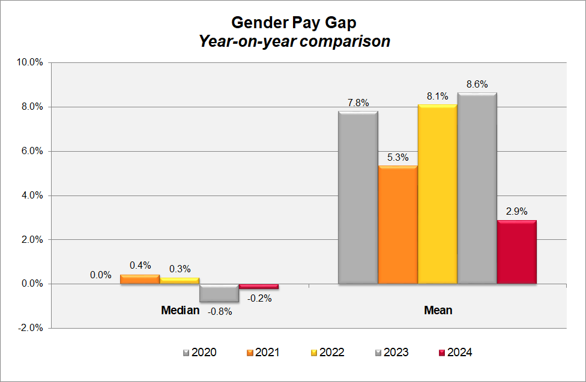

The median ratio remains low, while the gender pay gap as measured by the mean has decreased significantly since 2023. The decrease relates to several factors.

In the previous two years, the figures included significant numbers of consultants associated with Leonard Cheshire’s turnaround strategy and service delivery improvement initiatives. In the current figures, the number of consultants has reduced significantly, contributing to the narrowing of the pay gap this year.

If the relatively short-term impact of consultants is excluded, there has been a downward trend in the gender pay gap over the past three years. This can be attributed to the significant uplift in national living wage and the introduction of enhancements for hourly paid employees over this period. The higher proportion of males in frontline roles has also contributed to the lower pay gap this year.

# Proportion of male and female employees by quartile group

In line with the social care and charity sectors, Leonard Cheshire employs more women than men, with 74% of our employees being female, and 26% being male. (In 2022, these figures were 78% and 22% respectively.)

In the table below, we have divided our workforce into four equal groups (“quartiles”) ordered from lowest to highest paid.

The proportion of male and female employees in Leonard Cheshire in each of the quartiles is as follows:

|  |  |  |
| --- | --- | --- |
| Quartile groups | Female | Male |
| Lower | 76% | 24% |
| Lower middle | 70% | 30% |
| Upper middle | 72% | 28% |
| Upper | 78% | 22% |
| All | **74%** | **26%** |

The chart below shows the same quartile gender splits:

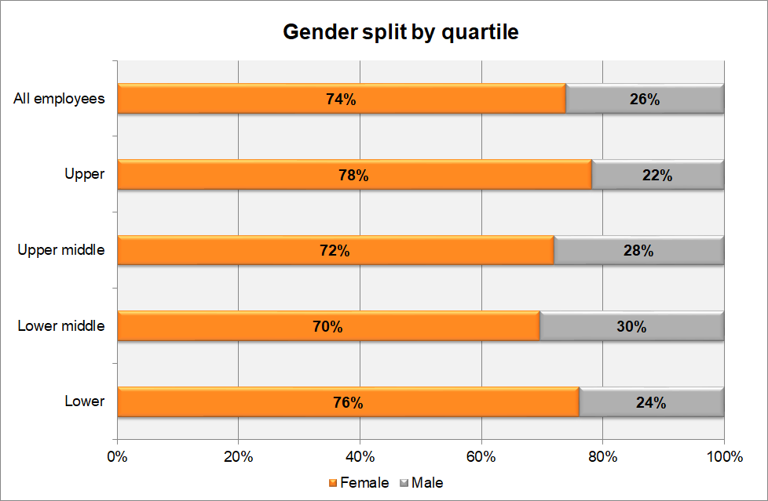

# Findings from our gender pay gap analysis

Around 94% of our employees are hourly workers in our UK care operations so the median pay rate is strongly influenced by the size of this group.

Because the pay framework of these hourly paid employees is standardised by role, this has resulted in very consistent pay levels between male and female employees for this group, contributing to the broadly neutral median gender pay gap for the organisation.

An integrated pay framework covers all salaried employees, based on the scale and level of complexity of the respective roles, so on an equivalent (“like for like”) basis, there is pay equity across these roles too.

Women are more strongly represented in less senior roles, which include both hourly paid social care roles and less senior salaried roles. This brings down the average earnings for female employees relative to their male colleagues. While women are well-represented at the senior levels of the organisation[3] making up 54% of these positions, this does not offset the impact of significantly higher proportions of women in less senior roles.

However, the impact of the escalating national living wage and the introduction of unsociable hours enhancements for frontline roles has contributed to the narrowing of the gender pay gap, as has the shift in demographics for this group, with proportionally more men in frontline roles than before.

# Responses to the gender pay gap analysis

Leonard Cheshire continues working to address our gender pay gap by:

* Continuing to ensure our reward frameworks enhance cross-organisational consistency and internal equity of pay.
* Continuing to encourage the culture of flexible working practices, to minimise career obstacles for working parents – responsibilities typically biased towards women.
* Building awareness of the structural gender bias in the social care and the charity sector and working consciously to counteract this.
* Collaborating with our Employee Inclusion Networks and the Colleague Support Network, to increase awareness and further build our organisation as an inclusive workplace.
* Ongoing review of our recruitment process to ensure fairness in our process and parity in the offers being made to new starters.
* Ongoing review of our recruitment practices to seek to attract more women into typically male-dominated roles, with particular focus on Executive team roles.
* Investing in leadership and skills development, to assist in career progression.
* Review of our talent management and career development processes, with due consideration of career progression of women in the organisation.

While the structural aspects of the gendered nature of the social care and charity sector will continue to challenge us in narrowing our gender pay gap, we are committed to working towards this goal, while we continue to build our organisation as an inclusive, fair, and empowering workplace.

Lynn Barbour

Head of Reward and Employee Engagement

Leonard Cheshire

March 2025

The data in this report is certified as accurate and is in line with statutory requirements.

Jon Forde

Executive Director People

Leonard Cheshire

March 2025

1. We are monitoring the progress of the Draft Equality (Race & Disability) Bill announced in the 2024 King’s Speech. The details of both ethnicity pay gap and disability pay gap reporting will be set out in regulations. As clarity emerges, we are committed to extending our pay gap reporting in line with the intent and requirements of the regulations.
2. All comparator figures are from Office of National Statistics (ONS) - Annual Survey of Hours and Earnings (ASHE) gender pay gap tables.
3. Senior and Executive Management